**TALLER DE PALABRAS PARÓNIMAS**

**Revise en el glosario de la guía que son las palabras parónimas y desarrolle los siguientes ejercicios.**

**1. Estas palabras son la solución para el crucigrama. Defínalas y diligencie el espacio correspondiente con lo indicado en los listados de horizontales y verticales de abajo.**

|  |  |
| --- | --- |
| Contesto: | Contexto: |
| Estático: | Extático: |
| Esotérico: | Exotérico: |
| Estirpe: | Extirpe: |
| Espiar: | Expiar: |
| Espirar | Expiro: |
| Seso: | Sexo: |
| Testo: | Texto: |



|  |  |  |  |  |  |  |  |  |  |  |  |  |  |  |  |  |  |  |  |  |  |  |  |  |  |  |  |  |
| --- | --- | --- | --- | --- | --- | --- | --- | --- | --- | --- | --- | --- | --- | --- | --- | --- | --- | --- | --- | --- | --- | --- | --- | --- | --- | --- | --- | --- |
|  |  |  |  |  |  |  |  |  |  |  |  |  |  | 5 |  |  |  |  |  |  |  |  |  |  |  |  |  | |
|  |  | 1 |  |  |  |  | 3 |  |  |  |  |  | 1 |  |  |  |  |  |  |  |  |  |  |  |  |  |  | |
|  |  |  |  |  |  |  |  |  |  |  |  |  |  |  |  |  |  |  |  |  |  |  |  |  |  |  |  | |
| 2 |  |  |  |  |  |  |  |  |  |  | 4 |  |  |  |  |  |  |  |  |  |  |  | 7 |  |  |  |  | |
|  |  |  |  |  |  |  |  |  |  | 3 |  |  |  |  |  |  |  |  |  |  | 9 |  |  |  |  |  | |  | |
|  |  |  |  |  |  |  |  |  |  |  |  |  |  |  |  |  |  |  |  | 6 |  | 2 |  |  |  |  |  | |
|  | 4 |  |  |  |  |  |  |  |  |  |  |  |  |  |  | 5 |  |  |  |  |  |  |  |  |  |  |  | |
|  |  |  |  |  |  |  |  |  |  |  |  |  |  |  |  |  |  |  |  |  |  |  |  |  |  |  |  | |
|  |  |  |  |  | 6 |  |  |  |  |  |  |  |  |  |  |  |  | 7 |  |  |  |  |  |  |  |  |  | |
|  |  |  |  |  |  |  |  |  |  |  |  |  |  |  |  |  |  |  |  |  |  |  |  |  |  |  |  | |
| 8 |  |  |  |  |  |  |  |  |  |  |  |  |  |  |  |  |  |  |  |  |  |  |  |  |  |  |  | |
|  |  |  |  |  |  |  |  |  |  |  |  |  |  |  |  |  |  |  |  |  |  |  |  |  |  |  |  | |
|  |  |  |  |  |  |  |  |  |  |  |  |  |  |  |  |  |  |  |  |  |  |  |  |  |  |  |  | |

**2. Busque palabras homófonas en la sopa de letras y rellene el espacio de color amarillo. Luego, escríbalas frente a la definición que corresponda en el cuadro.**

|  |  |  |  |  |  |  |  |  |  |  |  |  |  |  |
| --- | --- | --- | --- | --- | --- | --- | --- | --- | --- | --- | --- | --- | --- | --- |
| A | V | R | E | I | H | D | U | G | R | A | I | P | S | E |
| Y | J | P | O | Y | O | G | D | A | Y | L | U | B | I | C |
| A | F | A | Y | A | R | B | Z | L | J | Q | A | H | Q | E |
| V | Ñ | A | O | I | J | Ñ | R | L | A | Y | R | I | Z | X |
| Z | O | L | L | O | P | L | I | A | L | N | R | E | C | P |
| R | D | A | L | L | A | V | T | S | L | L | O | R | A | I |
| A | T | E | L | L | A | K | H | E | A | Z | L | B | Y | A |
| L | Q | A | Y | A | M | S | E | D | M | J | L | A | O | R |
| L | L | Z | J | C | Q | U | T | M | V | Q | O | Z | B | O |
| A | Y | A | M | V | T | N | U | O | Y | O | R | R | A | O |

|  |  |
| --- | --- |
| Envuelvo en forma de rollo. | Riachuelo. |
| Del verbo caer. Islote. | Endurecimiento de la piel. |
| Cercado. | Forma del verbo ir. |
| Dejar el agua al fuego hasta que. | Planta pequeña. |
| Red. | Indígena. |
| Ave de corral. | Asiento de piedra. |
| Cortar una red. | Causar desmayo. |
| Desmenuza. | Línea. |
| Sufrir culpas. | Observar acechar. |

**3. Escriba en el cuadro de abajo, el significado de por lo menos 10 parejas de palabras homófonas: “FAVOR ESCOGER DE MANERA ALEATORIA LAS PAREJAS”**

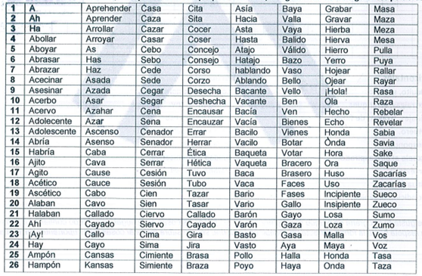

|  |  |
| --- | --- |
| Barón: | Varón: |
|  |  |
|  |  |
|  |  |
|  |  |
|  |  |
|  |  |
|  |  |
|  |  |
|  |  |

**Elaborado por Instructor Wilmer Meza ajustado por Diana Luisa Pinzón**